Used Book Sharing System

Use-Case Specification:

Used Book Sharing System Use-cases

Version 2.3

Revision History

|  |  |  |  |
| --- | --- | --- | --- |
| **Date** | **Version** | **Description** | **Author** |
| 12/11/2019 | 1.0 | Initial version | Bui Quang Thang |
| 13/11/2019 | 1.1 | Fill Offer book  Fill View offering books  Fill edit offering book  Add Use-case diagram | Bui Quang Thang |
| 13/11/2019 | 1.2 | Add Login, Logout, Create account Use-Case Specification | Dang Duc Trung |
| 13/11/2019 | 1.3 | Edit Use-Case Diagram | Dang Duc Trung |
| 14/11/2019 | 1.4 | Fill Delete offering book | Bui Quang Thang |
| 14/11/2019 | 1.5 | Fill Comment on book  Fill Rate book  Edit Use-case diagram | Bui Quang Thang |
| 15/11/2019 | 1.6 | Add Special Requirement for all Use-Cases | Dang Duc Trung |
| 15/11/2019 | 1.7 | Edit Use-Case Diagram | Tran Thuan Thanh |
| 16/11/2019 | 1.8 | Edit Use-Case Model and Use Case specifications | Dang Duc Trung |
| 16/11/2019 | 1.9 | Edit Use-case Diagram | Tran Thuan Thanh |
| 16/11/2019 | 2.0 | Add Ban User, Delete post use-case specifications  Edit Use-case diagram | Bui Quang Thang |
| 17/11/2019 | 2.1 | Review and clear & align text | Bui Quang Thang |
| 24/11/2019 | 2.2 | Edit Modal & specification  Add: report,  wish list,  favorite list,  view profile, edit profile,  change password | Bui Quang Thang |
| 27/11/2019 | 2.3 | Update model & specifications:  Book blog,  Online chat,  Book note,  Support system, | Bui Quang Thang |
|  |  |  |  |

Table of Contents

1. Use-case Model 4

2. Use-case Specifications 5

2.1 Use-case: User Login 5

2.2 Use-case: Create new account 5

2.3 Use-case: Search for book 6

2.4 Use-case: View book’s details 6

2.5 Use-case: Post comment 6

2.6 Use-case: Rate book 7

2.7 Use-case: Offer book 7

2.8 Use-case: View offering books 8

2.9 Use-case: Edit offering book 8

2.10 Use-case: Delete offering book 9

2.11 Use-case: Ban User 9

2.12 Use-case: Delete book 10

2.13 Use-case: Report 10

2.14 Use-case: Wish list 11

2.15 Use-case: Favorite list 11

2.16 Use-case: View account profile 12

2.17 Use-case: Edit account profile 12

2.18 Use-case: Change password 12

2.19 Use-case: Book blog 13

2.20 Use-case: Book note 13

2.21 Use-case: Online chat 14

2.22 Use-case: System Support 14

# Use-case Model

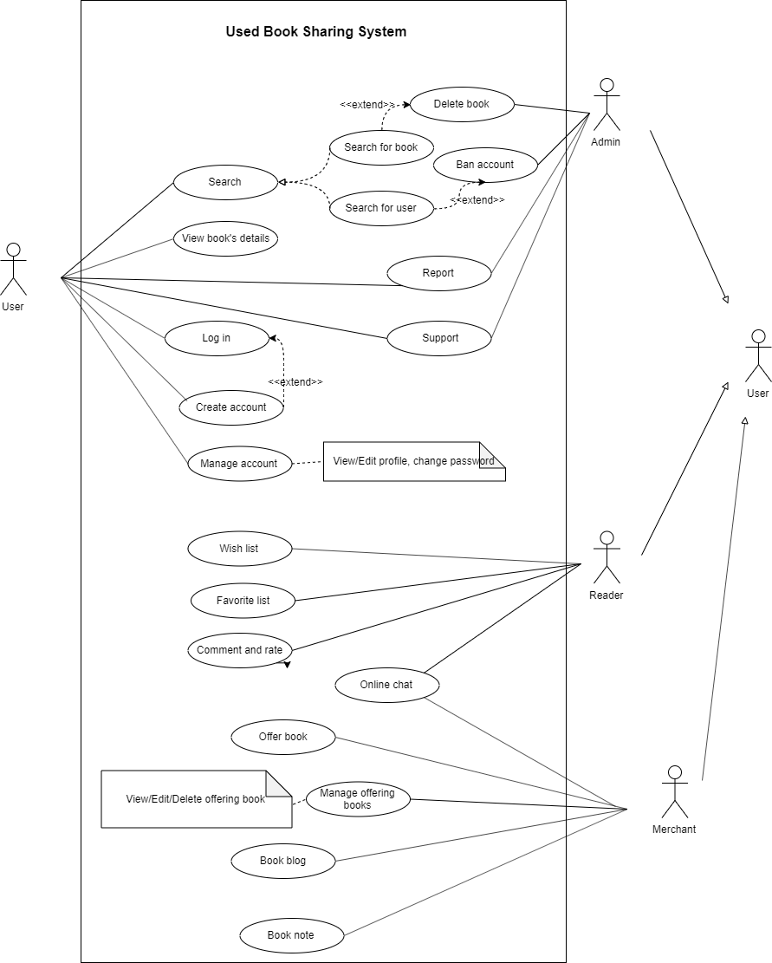

# Use-case Specifications

## Use-case: User Login

|  |  |
| --- | --- |
| Use case Name | Login |
| Brief description | This use case describes how the User login into book sharing website. |
| Actors | Reader/Merchant/Administrator |
| Basic Flow | 1. At the homepage, the user choose icon avatar to enter login screen 2. User enter username and password into corresponding fields 3. User click Login button 4. System check information and return successful login result. 5. User back to home page with username next to icon avatar. |
| Alternative Flows | **Alternative flow 1: User forgot password**   1. User click forgot password below password field. 2. User enter verified information to reset password.   **Alternative flow 2: User enter wrong username or password**   1. System notice username/password invalid 2. System suggest user provide username/password again   **Alternative flow 3: User haven’t account yet**   1. User click Sign up 2. User switch to create account screen 3. User enter information to create account 4. System check information and create account for user. |
| Pre-conditions | User return to homepage |
| Post-conditions | Reader successful login into system to comment or vote for merchant.  Merchant successful login into system to upload book.  Administrator successful login into system to manage all account and keep website don’t have illegal action. |
| Special Requirement | Can use more than 1 way to login (Website’s account, facebook account, gmail account). |

## Use-case: Create new account

|  |  |
| --- | --- |
| Use case Name | Create new account |
| Brief description | This use case describes how the user create account. |
| Actors | Reader/Merchant/Administrator |
| Basic Flow | 1. At the homepage, the user choose icon avatar to enter login screen 2. User click Sign up to create account 3. User enter create account screen. 4. User provide information for system. 5. System check information to verify account. 6. System return successful respond for user. 7. Return to homepage with account logged in |
| Alternative Flows | **Alternative flow 1: User provide invalid information**   1. System return invalid notification. 2. System ask user provide information again. |
| Pre-conditions | User haven’t account yet. |
| Post-conditions | User have verified account can login into system.  Reader can use this account to comment or vote for merchant.  Merchant can use this account to upload book.  Administrator with responding account can manage website. |
| Special Requirement | System verify information don’t take more than 2 minutes.  User can use account immediately. |

## Use-case: Search for book

|  |  |
| --- | --- |
| Use case Name | Search for book |
| Brief description | This use case describes how the user searches for a book. |
| Actors | Reader/Merchant/Administrator |
| Basic Flow | 1. User inputs book information in search field. 2. User selects ‘Search’ 3. System shows a list of books which related to the search key. |
| Alternative Flows | 3a. There is not any book related   1. System shows an empty list. |
| Pre-conditions | none |
| Post-conditions | An empty list or a list with at least 1 book is showed in the user’s screen. |
| Special Requirement | System response time must less than 1 minutes. |

## Use-case: View book’s details

|  |  |
| --- | --- |
| Use case Name | View book’s details |
| Brief description | This use case describes how the user view a book’s information. |
| Actors | Reader/Merchant/Administrator |
| Basic Flow | 1. In the list returned from searching, User clicks on a book. 2. System shows a page with chosen book’s information. |
| Alternative Flows | none |
| Pre-conditions | User has a list of books. |
| Post-conditions | New page about the chosen book must be showed up. |
| Special Requirement | System response time must less than 1 minutes. |

## Use-case: Post comment

|  |  |
| --- | --- |
| Use case Name | Post comment |
| Brief description | This use case describes how the User can comment on a book. |
| Actors | Seller, Reader, Administrator |
| Basic Flow | 1. User type comments in the comment section of a book. 2. User type public name in the name box or leave it empty. 3. User select ‘Post’ 4. System updates comments on that book. 5. System notifies user about successful comment. |
| Alternative Flows | none |
| Pre-conditions | User have to be viewing book’s details. |
| Post-conditions | A comment is added to the book’s comment section. |
| Special Requirements | none |

## Use-case: Rate book

|  |  |
| --- | --- |
| Use case Name | Rate book |
| Brief description | This use case describes how the User can rate a book. |
| Actors | Seller, Reader, Administrator |
| Basic Flow | 1. User selects a grade for a book in the Rate section. 2. System updates rate point for that book. 3. System notifies user about successful rating. |
| Alternative Flows | None |
| Pre-conditions | - User have to log in successfully.  - User have to be viewing book’s details. |
| Post-conditions | Rate point is updated for that book. |
| Special Requirements | Rate action must be simple such as 1-step action. |

## Use-case: Offer book

|  |  |
| --- | --- |
| Use case Name | Offer book |
| Brief description | This use case describes how the Seller can offer a book. |
| Actors | Seller |
| Basic Flow | 1. User selects ‘Offer book’ from web page. 2. System displays a form in where there are some information required. 3. User fills out the form and then selects ‘offer’ 4. System adds new offering book to user’s offering book list. 5. System notifies user about successful uploading. |
| Alternative Flows | 3a. User doesn’t fill all required sections.  3a.1 System informs user about sections required.  3a.2 Return to step #3  4a. There is already the same offering book in user’s offering book list.  4a.1 Increase quantity of the existing offering book.  4a.2 Go to step #5 |
| Pre-conditions | User is required to have an account and log in successfully. |
| Post-conditions | The user successfully adds new offering book to the offering list or increases quantity of the existing item in the cart. |
| Special Requirements | - User must accept User Book Sharing System’s policy.  - System’s response time must be less than 1 minute. |

## Use-case: View offering books

|  |  |
| --- | --- |
| Use case Name | View offering books |
| Brief description | This use case describes how the Seller can view his/her offering books. |
| Actors | Seller |
| Basic Flow | 1. User selects ‘Offering book list’ from web page. 2. System displays list of offering books which user uploaded and quantity of books in list. |
| Alternative Flows | 2a. There is not any offering book in list.  2a.1 System shows caption about empty. |
| Pre-conditions | User is required to have an account and log in successfully. |
| Post-conditions | A list of offering books displayed in user’s screen. |
| Special Requirements | System’s response time must be less than 1 minute. |

## Use-case: Edit offering book

|  |  |
| --- | --- |
| Use case Name | Edit offering book |
| Brief description | This use case describes how the Seller can edit his/her offering book. |
| Actors | Seller |
| Basic Flow | 1. User selects ‘Edit’ below a book in the offering book list. 2. System displays a form in where there are current information of that book. 3. User modifies information and select ‘Save’. 4. System updates information of that offering book. 5. System notifies user about successful editing. |
| Alternative Flows | 3a. User doesn’t fill all required sections.  3a.1 System informs user about sections required.  3a.2 Return to step #3 |
| Pre-conditions | - User is required to have an account and log in successfully.  - User has at least 1 offering book. |
| Post-conditions | The user successfully edits information of an offering book. |
| Special Requirements | - System’s response time must be less than 1 minute. |

## Use-case: Delete offering book

|  |  |
| --- | --- |
| Use case Name | Delete offering book |
| Brief description | This use case describes how the Seller can delete his/her offering book. |
| Actors | Seller |
| Basic Flow | 1. User selects ‘Delete’ below a book in the offering book list. 2. User verifies deleting. 3. System deletes that offering book. 4. System notifies user about successful deleting. |
| Alternative Flows | none |
| Pre-conditions | - User is required to have an account and log in successfully.  - User has at least 1 offering book. |
| Post-conditions | An offering book or multiples offering books which are the same type is/are completely deleted from user’s book list. |
| Special Requirements | System’s response time must be less than 1 minute. |

## Use-case: Ban User

|  |  |
| --- | --- |
| Use case Name | Ban User |
| Brief description | This use case describes how the Admin bans an user. |
| Actors | Administrator |
| Basic Flow | 1. Admin selects ‘Ban user’ feature and inputs user’s id. 2. Or Admin selects search to find user first before input user’s id. 3. Admin select ‘Ban’ 4. System asks Admin to ensure to ban user. 5. Admin agrees 6. System checks if user can be banned. 7. System bans user and updates database . 8. System notifies Admin about successful deleting. |
| Alternative Flows | 5a. Admin cancel  5a.1 finish operation.  6a. User not found or user is not be banned.  9a.1 System notifies Admin about failed deleting. |
| Pre-conditions | None |
| Post-conditions | An user is banned. |
| Special Requirement | System must send to banned user’s email about being banned. |

## Use-case: Delete book

|  |  |
| --- | --- |
| Use case Name | Delete book |
| Brief description | This use case describes how the Admin deletes any offering book. |
| Actors | Administrator |
| Basic Flow | 1. Admin selects ‘Delete book’ feature and inputs book’s id. 2. Or Admin selects search to find book first before input book’s id. 3. Admin select ‘Delete’ 4. System asks Admin to ensure to delete book. 5. Admin agrees 6. System checks if the book can be deleted 7. System process and update database 8. System notifies Admin to verify about successful deleting. |
| Alternative Flows | 5a. Admin cancel  5a.1 finish operation.  6a. User not found or user is not be banned.  9a.1 System notifies Admin about failed deleting. |
| Pre-conditions | None |
| Post-conditions | An book is deleted permanently. |
| Special Requirement | System must send to banned user’s email about deleting book. |

## Use-case: Report

|  |  |
| --- | --- |
| Use case Name | Report |
| Brief description | This use case describes how the Reader reports book or seller to Admin. |
| Actors | Reader, Administrator |
| Basic Flow | 1. Reader selects ‘Report’ at the book details screen 2. Reader selects topic and write description about bad things. 3. Reader sends report to system admin. 4. Admin receives report and checks. 5. Admin takes action and send response message to reader. |
| Alternative Flows | none |
| Pre-conditions | Reader must log in successfully. |
| Post-conditions | Message about action from Admin is sent to reader. |
| Special Requirement | none |

## Use-case: Wish list

|  |  |
| --- | --- |
| Use case Name | Wish list |
| Brief description | This use case describes how the User registers for a book. |
| Actors | User |
| Basic Flow | 1. User selects ‘Wish list’ and add information about desired book. 2. System checks and notifies user when the desired book is available. |
| Alternative Flows | 2a Not any book for a long time  2a.1 Systems informs user about wish book time out. |
| Pre-conditions | User must have an account and log in successfully. |
| Post-conditions | User receives notification about available desired book. |
| Special Requirement | Notification should contain link to the available book. |

## Use-case: Favorite list

|  |  |
| --- | --- |
| Use case Name | Favorite list |
| Brief description | This use case describes how the User add a book to favorite list. |
| Actors | User |
| Basic Flow | 1. User select ‘add to favorite’ at the book details screen. 2. System updates book to user’s favorite list. 3. User go to Favorite list to view list of favorite books. |
| Alternative Flows | none |
| Pre-conditions | User must have an account and log in successfully. |
| Post-conditions | A book is added to user’s Favorite list. |
| Special Requirement | None |

## Use-case: View account profile

|  |  |
| --- | --- |
| Use case Name | View account profile |
| Brief description | This use case describes how the User views his/her profile. |
| Actors | User |
| Basic Flow | 1. User selects ‘view profile’ 2. System sends user’s profile to user. |
| Alternative Flows | none |
| Pre-conditions | User must have an account and log in successfully. |
| Post-conditions | A profile form is showed in the user’s screen. |
| Special Requirement | None |

## Use-case: Edit account profile

|  |  |
| --- | --- |
| Use case Name | Edit account profile |
| Brief description | This use case describes how the User edits his/her profile. |
| Actors | User |
| Basic Flow | 1. User selects ‘edit profile’ 2. System sends profile form to user. 3. User edits form and save information. 4. System update user’s profile. |
| Alternative Flows | 4a. User leaves critical information empty  4a.1 System informs user about missing information and doesn’t update user’s profile. |
| Pre-conditions | User must have an account and log in successfully. |
| Post-conditions | An edited profile is showed in the user’s screen. |
| Special Requirement | None |

## Use-case: Change password

|  |  |
| --- | --- |
| Use case Name | Change password |
| Brief description | This use case describes how the User changes his/her account’s password. |
| Actors | User |
| Basic Flow | 1. User selects ‘change password’ 2. User fills in old password and new password. 3. User requests ‘change’ to system. 4. System checks and responds to user about successful password changing. |
| Alternative Flows | 4a. User wrong verifying new password.  4a.1 System informs user about wrong password and doesn’t update user’s profile.  4b User wrong old password  4b.1 System informs user about wrong old password and doesn’t update user’s profile. |
| Pre-conditions | User must have an account and log in successfully. |
| Post-conditions | New password was assigned to user’s account. |
| Special Requirement | An email must be sent to user’s mail box to notify her/him about password change before really assign new password to user’s account. |

## Use-case: Book blog

|  |  |
| --- | --- |
| Use case Name | Book blog |
| Brief description | This use case describes how the Seller creates book introducing blog for an offering book. |
| Actors | Seller |
| Basic Flow | 1. Seller goes to details of an offering book and select ‘add blog’. 2. Seller writes blog and click ‘save’ 3. System updates book blog for that selected book and show notifications about success updating. |
| Alternative Flows | None |
| Pre-conditions | User must have an account and log in successfully.  User must have at least 1 offering book. |
| Post-conditions | The selected offering book is updated with an introducing blog. |
| Special Requirement | Blog editor must support various text format, insert link, image, icon. |

## Use-case: Book note

|  |  |
| --- | --- |
| Use case Name | Book note |
| Brief description | This use case describes how the Seller writes note for an offering book.  Book note may includes the way for reader gets the book. |
| Actors | Seller |
| Basic Flow | 1. Seller goes to details of an offering book and select ‘add/edit note’. 2. Seller writes note and click ‘save’ 3. System updates note for that selected book and show notifications about success updating. |
| Alternative Flows | none |
| Pre-conditions | User must have an account and log in successfully.  User must have at least 1 offering book. |
| Post-conditions | The selected offering book is updated with new note. |
| Special Requirement | Note editor must support only plain text without link, image or icon, etc… |

## Use-case: Online chat

|  |  |
| --- | --- |
| Use case Name | Online chat |
| Brief description | This use case describes how the Reader makes a direct conversation with Seller. |
| Actors | Reader, Seller |
| Basic Flow | 1. Reader go to a book details and select ‘chat to seller’ 2. A chat box appears 3. Reader writes message and select ‘send’ 4. System redirects message to Seller. 5. Seller writes reply message and select ‘send’ 6. System returns message to Reader. 7. Reader closes chat box to finish conversation. |
| Alternative Flows | 7a. Reader is not satisfied  7a.1 return to step #3 |
| Pre-conditions | Seller and Reader must have an account and log in successfully. |
| Post-conditions | Reader had an online chat with seller. |
| Special Requirement | None. |

## Use-case: System Support

|  |  |
| --- | --- |
| Use case Name | System support |
| Brief description | This use case describes how the User gets support from system Admin. |
| Actors | User (Reader, Seller) , Admin |
| Basic Flow | 1. User selects ‘support’ from menu. 2. User waits for an available Admin. 3. System informs User about available Admin and starts conversation between two ones. 4. User sends question. 5. Admin replies with answer. 6. User is satisfied and close conversation. |
| Alternative Flows | 3a. No available Admin  3a.1 System informs user about failing to find admin.  6a. User haven’t been satisfied  6a.1 returns step #4 |
| Pre-conditions | User must have an account and log in successfully. |
| Post-conditions | Reader gets appropriate instructions from system admin. |
| Special Requirement | Response time for search admin is less than 1 minutes.  Maximum serve time for a user is less than 10 minutes. |